B

**Bonded Title Information**

Why do I need a Bonded Title?

A Georgia bonded title is required if a vehicle owner does not physically possess the title to his or her newly purchased vehicle. If the owner is unable to prove ownership of the vehicle in Georgia due to a missing car title, stolen or defective document, there is an option to provide appropriate security in the form of a title bond. By posting a Georgia title bond, the principal guarantees that the vehicle was not stolen or sold under any fraudulent pretenses.

What is a Bonded Title?

A bonded title is when an insurance company writes a surety bond on a vehicle. A surety bond, in general, is a guarantee of specific obligation or contract. An auto title surety bond provides a guarantee of ownership to a state's Department of Motor Vehicles. A title bond is required to satisfy the ownership documentation for a vehicle that does not have other forms of documentation available.

Vehicles that ***CANNOT*** be Bonded?

The vehicle you are trying to get bonded ***CANNOT*** be abandoned, junked, stolen or in any other pending lawsuits and it must be legally in your possession.

Bonded Titles take an average of 90 days to come back from the State of Georgia once we have applied for it in our office.

**Steps to obtaining a Bonded Title**

[**https://dor.georgia.gov/bonded-vehicle-title**](https://dor.georgia.gov/bonded-vehicle-title)

1. Obtain vehicle value from the Tag Office
2. Take Bill of Sale or Title and vehicle value to an insurance company that writes Title Bonds to get the Bond process started.
3. Call Law Enforcement and have an officer complete the T-22B Certification of Inspection Form. [T-22B-certification-inspection](https://dor.georgia.gov/t-22b-certification-inspection) If the vehicle is currently located in Brooks County you may call 229-263-4262 & request for a deputy to come out to inspect the vehicle and complete the form.
4. For a free vehicle history report visit [free-vehicle-history-reports](https://www.carsforsale.com/free-vehicle-history-reports).. Be sure that you have entered the VIN correctly. Once report is completed you MUST PRINT the report or download report so that it can be emailed to us once you are present in the office.

If your Vehicle History Report indicates that your vehicle was last titled in a state other than Georgia, you will need to obtain a certified title history from that state, we will assist you with this part.

1. Once you have completed all the steps mentioned above, bring all paperwork to the Tag Office and we will assist you from there.

NOTE: The title must be applied for within six months of the bond’s issue date. The minimum acceptable bond amount is $5000.00. For verification of the bond amount, your insurance company may call the Motor Vehicle Division 855-406-5221 or your local tag office.

Forms you will return to us:

1. MV-46 (Issued by Insurance Company)
2. MV-46A (Issued by Insurance Company)
3. Power of Attorney (Issued by Insurance Company)
4. T-22B completed by Law Enforcement
5. Bill of Sale or Title
6. Driver's License
7. Proof of GA insurance if purchasing a tag

If you have any questions, please don't hesitate to call or visit our office. 229-263-4586

You are welcome to use the insurance company of your choice, as long as they write Title Bonds. However, Holwell-Fletcher Insurance Agency, 603 E Screven St, Quitman, GA 31643, 229-263-4136, does process a lot of Bonded Titles and they are very familiar with them.

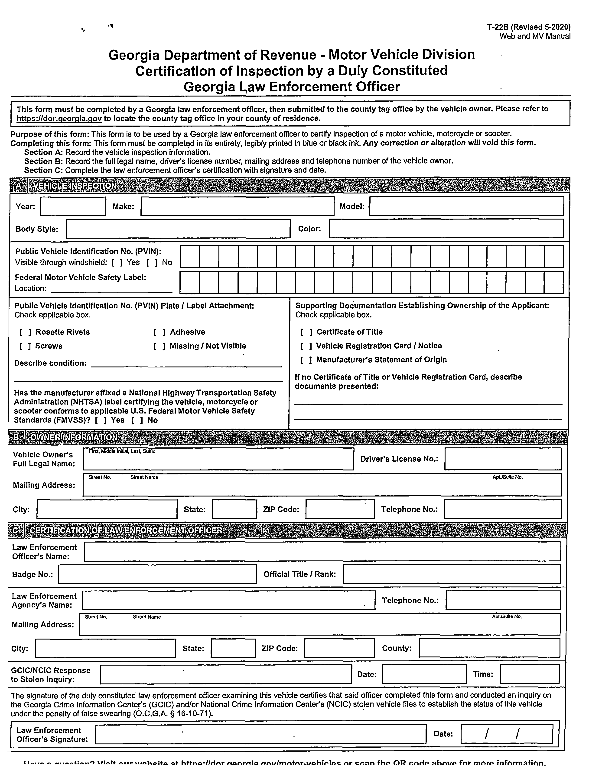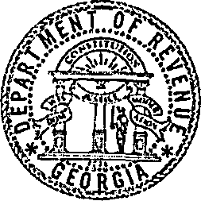

**Georgia Department of Revenue - Motor Vehicle Division Certification of Inspection by a Duly Constituted**

**Georgia Law Enforcement Officer**

T-22B (Revised 5-2020) Web and MV Manual

This form must be completed by a Georgia law enforcement officer, then submitted to the county tag office by the vehicle owner. Please refer to [https://dor.qeorqia.gov](https://dor.qeorqia.gov/) to locate the county tag office in your county of residence.

Purpose of this form: This form is to be used by a Georgia law enforcement officer to certify inspection of a motor vehicle, motorcycle or scooter. Completing this form: This form must be completed in its entirety, legibly printed in blue or black ink. Any correction or alteration will void this *form.*

Section A: Record the vehicle inspection information.

Section B: Record the full legal name, driver's license number, mailing address and telephone number of the vehicle owner. Section C: Complete the law enforcement officer’s certification with signature and date.

Year:

|  |  |
| --- | --- |
| **Make:** | **M o del:'** |

Body Style: Color:

Public Vehicle Identification No. (PVIN): Visible through windshield: [ ] Yes [ ] No

Federal Motor Vehicle Safety Label: Location:

Public Vehicle Identification No. (PVIN) Plate / Label Attachment: Check applicable box.

Supporting Documentation Establishing Ownership of the Applicant: Check applicable box.

[ ] Rosette Rivets [ ] Screws

Describe condition:

[ ] Adhesive

[ ] Missing / Not Visible

I ] Certificate of Title

[ ] Vehicle Registration Card / Notice

[ ] Manufacturer’s Statement of Origin

If no Certificate of Title or Vehicle Registration Card, describe documents presented:

Has the manufacturer affixed a National Highway Transportation Safety

Administration (NHTSA) label certifying the vehicle, motorcycle or scooter conforms to applicable U.S. Federal Motor Vehicle Safety Standards (FMVSS)? [ ] Yes [ ] No

Vehicle Owner’s Full Legal Name:

Mailing Address:

City:

First, Middle Initial. Last, Suffix

Driver’s License No.:

AptJSuite No.

* **GERIIFICATIQN**

|  |  |  |
| --- | --- | --- |
| **State:** | **ZIP Code:** | **Telephone No.:** |

|  |  |
| --- | --- |
| **Law Enforcement Officer’s Name:** |  |
| **Badge No.:** | **Official Title / Rank:** |

Law Enforcement Agency’s Name:

Mailing Address:

Telephone No.:

ApUSuite No.

|  |  |  |  |  |
| --- | --- | --- | --- | --- |
| **City:** | **State:** | **ZIP Code:** | **County:** |  |
| **GCIC/NCIC Response to Stolen Inquiry:** |  | **Date:** |  | **Time:** |
| **The signature of the duly constituted law enforcement officer examining this vehicle certifies that said dfficer completed this form and conducted an inquiry on the Georgia Crime Information Center's (GCIC) and/or National Crime Information Center's (NCIC) stolen vehicle files to establish the status of this vehicle under the penalty of false swearing (O.C.G.A. § 16-10-71).** | | | | |
| **Law Enforcement Officer’s Signature:** | **•** |  | **Date:** | **/ /** |

Ll»w. o x/iotf /Mic urn Ueito tittle * //r l/\r n o A rn ia n A u /m A t A r .u o h frlo c n r c rsm thp O R r.nrip ahm /A fo r m o m in fo rm atio n.